

hingram447@c2kni.net
Tel:02866348598

March 2018 Newsletter

School Closings: Spring Term
The school will be closed on Monday 19th March for St Patrick’s Day. The school will close on Wednesday 28th March at 12 noon for the Easter Holidays and will re-open on Monday 9th April for the summer Term.

Camogie

Congratulations to our Year Seven girls who have won the Fermanagh Camogie final. Well Done girls.



School starts at 9.10 a.m sharp.Please ensure all children are on time for school as late arrivals can cause a lot of disruption to classes.

Literacy Week 5th - 9th March

This week we are doing lots of different activities associated with our Literacy.

Year Five, Six and Seven are doing Paired and Shared Reading with P1/2/3 every afternoon.

Book Character Day
Children may come to school on Friday 9th March dressed up as their favourite character from a story.

Illustrator
Ian Jackson – Illustrator is coming to the school on Friday 9th March to work with KS2 children illustrating and animating books.

Laura Quinn – Children’s author is coming to the school to work with children from all classes on Monday 5th March.

We are all designing book covers of our favourite books which you can see on display in the foyer.

Movie Night is on Friday 9th March.

First Penance will take place on in St Mary’s Church on Tuesday on 13th March at 11.00 a.m. All Year Four parents are welcome.

Peace Proms

We had an amazing day at the peace proms on Sunday 25th February. Lots of photos and videos on the website.

Accelerated Reading Millionaire

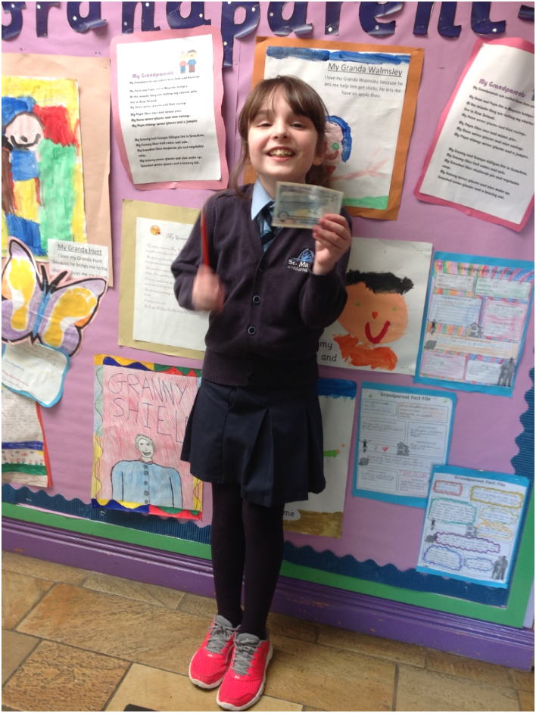
Congratulations to Luchia who is our new Accelerated Reading Millionaire


Book Fair
The Book Fair will be coming to the school from 8th March to 14th March. If any parents are available to help out in the mornings from 9.00-9.15 a.m or in the evenings from 3.15-3.30 p.m we would really appreciate your help. Please let Miss Tracey know if you can help.

Gardening Club

If anyone has the skills or knows anyone who has, maybe grannies/grandas etc to help out at a gardening club or with our Eco-Schools we would really appreciate the help. Let us know sure. Thanks.

Dinner Money

Dinner Money must be paid for on Mondays please, Please send money in with your child’s name,class and the date .
Please be advised that the school can no longer accept Bank of England, Bank of Scotland, Royal Bank of Scotland or Clydesdale Bank of Scotland £5 or £10 paper notes or old £1 coins.
Thanks very much.


Movie Night

The PFTA are organising a movie night on Friday 9th March here in the school from 7.00 p.m to 9.00 p.m. All children are welcome to attend. Popcorn and drinks will be provided by the PFTA.The cost will be £5 per child or £10 per family (2 children or more). Movie Night is only for children who attend this school. Thanks.

Football
Football for pupils from year 5-7 will take place every Tuesday afternoon from 3.15-4.15 with Miss McNulty and Mrs Miller.


Netball
Netball will begin on Thursday 8th March from 3.15 -4.15, girls from Year 5-7 should all come along and try it out. Reply Slip below.

---------------------------------------------------------------------------------------------------

Reply Slip

My child ____________________will be going to Netball afterschool on Thursdays from 3.15 -4.15 beginning 8th March.

She will be collected by________________________________.

Signed:_________________Parent/Guardian

